Fall 2020 T-Ball Coaches
Handbook

Mission Statement

The mission of Rome-Floyd Parks and Recreation Authority is to provide high quality, diverse, and accessible programs, services, and facilities that enhance the quality of life for all ages, cultures, and abilities.

Philosophy of Rome-Floyd Parks & Recreation Authority Baseball, Softball, and T-Ball

It is the intent of Rome-Floyd Parks and Recreation Authority to offer a program on an equal opportunity basis. It is the belief of Rome-Floyd Parks and Recreation Authority that competing in youth sports is crucial to developing character and self-esteem. Rome Floyd Parks and Recreation Authority also believes that lessons learned in competition can be applied in all life endeavors. Therefore, all individuals wishing to participate will not be discouraged from doing so. Teams are organized to maximize participation for all. Each participant who is dressed out and fit to play will play. Rome-Floyd Parks and Recreation Authority views all volunteer coaches as an integral component to the success of the program. Cooperation and communication are essential to maintain a quality experience for all. Coaches should strive to maintain a good working relationship with parents, players, and the program coordinator. Participants will reflect the character and attitude of the coaching staff. Therefore, it is imperative that all coaches display and model excellent sportsmanship and high moral character at all times. Coaches should refrain from any action that would tarnish their reputation with the teams in their league or the program.

Governing Rules

The governing body of the Rome-Floyd Parks and Recreation Authority Baseball, Softball, and T-Ball program will be composed of Rome-Floyd Parks and Recreation Authority Staff. Any rules not covered by Rome-Floyd Parks and Recreation will be covered first by the Georgia Recreation and Parks Association, then by Georgia High School Association Rules.

Contents
Mission Statement | 1
Sports Division Contents | 2
Contacts | 3
Facility Locations | 4
Article I Coaches' Information | 5
Article II Team Formation / Eligibility / Weather Policy | 9
Article III Game /Practice Scheduling / Awards / GRPA Tournament Teams | 11
Article IV General T-Ball / Baseball Rules | 13
Article V 6U Coach Pitch League General Information and Rules | 16
Rome-Floyd Parks & Recreation Fall 2020 Youth Baseball Calendar | 18

Sports Division Contacts

Sports Program Manager
Rick Haase | Direct Office: (706) 295-7324  Cell Phone: (706) 252-1337 | haaser@floydcountyga.org
Assistant Sports Manager
Jeremiah Blanton | Direct Office: (706) 291-0767  Cell Phone: (706) 252-1156 | blantons@floydcountyga.org
Sports Coordinator
Jay Houston | Direct Office: (706) 291-6864  Cell Phone: (706) 676-8570 | houstonj@floydcountyga.org
Sports Coordinator
Adam Mull | Direct Office: (706) 314-1320  Cell Phone: (706) 252-6438 | mulla@floydcountyga.org
Sports Administrative Specialist
Faith Mount | Direct Office: (706) 290-7676  Cell Phone: (706) 235-4166 | mountf@floydcountyga.org

Main Office: 706-291-0766

All schedules, rules, and scores can be found at http://www.teamsideline.com/sites/rfpra/home

Game Facilities

Alto Park
Upper Alto (Fields 1-5) | Lower Alto (Fields 6-8)
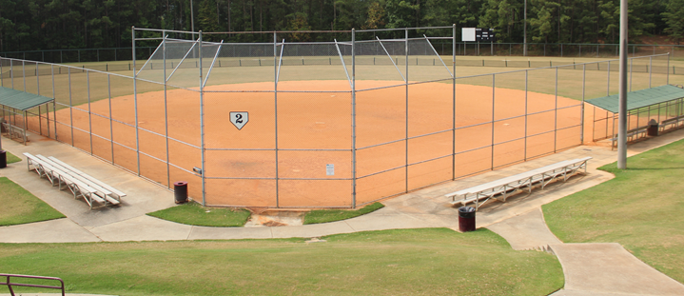 | 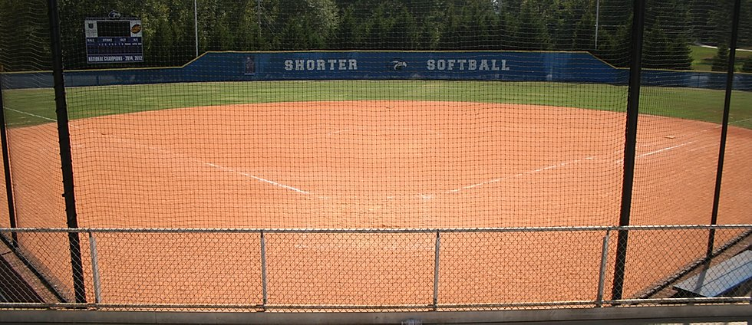
1014 Burnett Ferry Road
Rome, GA 30165
Riverview Park (Behind the Levee) | Hugh Selman Baseball Complex (North Floyd)
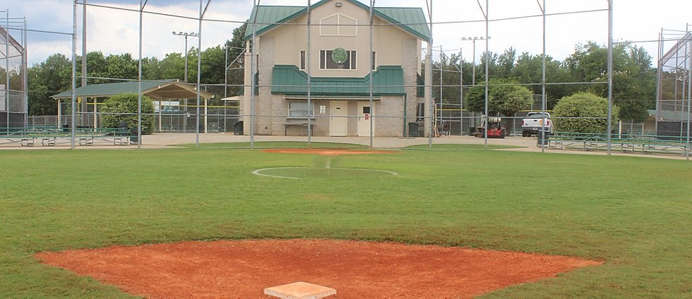 | 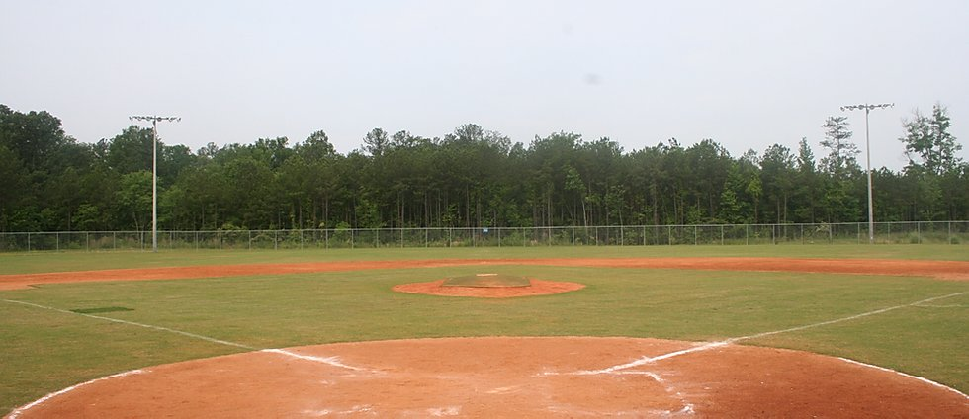
255 Frost Drive  Rome, GA 30165 | 102 North Floyd Park Road  Rome, GA 30165

Practice Facilities

Armuchee Park | Coosa Park
539 Jones Mill Road NE | 52 Krannert Drive NW
Rome, GA 30165 | Rome, GA 30165
Etowah Park | Garden Lakes
1325 Kingston Highway | 2903 Garden Lakes Boulevard
Rome, GA 30165 | Rome, GA 30165
Midway Park | Riverside Park
125 Midway Park Road SE | 215 Chatillon Road
Rome, GA 30173 | Rome, Georgia 30161
Shag Williams Park (Shannon) | Wolfe Park (Lindale)
40 Minshew Road NE | 106 Park Avenue
Shannon, GA 30172 | Rome, GA 30147
Article I

Coaches' Information

Rome-Floyd Parks and Recreation encourages anyone who is interested in being a positive force in a child’s life to contact a recreation staff member and fill out a coaching application. Coaches are role models for teaching the fundamentals of the sport, sport skills, tactics and sportsmanship. Coaches are responsible for their personal conduct and behavior, as well as, the conduct and behavior of players. Coaches are required to follow the Rome-Floyd Parks and Recreation guidelines at all times. A coach who does not follow the guidelines provided by the Rome-Floyd Parks and Recreation will need to meet with the League Coordinator in order to continue to coach. All volunteer coaches shall be “at will coaches,” and may be discharged by the Rome-Floyd Parks and Recreation with or without cause. Only coaches who have been approved by the Rome-Floyd Parks and Recreation will be allowed to go on the field of play or court during practices and games.

Guidelines for all Coaches
- Coaches participating in Rome-Floyd Parks and Recreation youth sports shall:
- Be reliable, and on time. (The first to arrive and the last to leave...)
- Be responsible for distributing a game/practice schedule to parents/guardians prior to the beginning of the season.
- Have with you, the Emergency Contact Information forms for each child on the team at all practices and games that is provided on your roster given to you by RFPR.
- Rome-Floyd Parks and Recreation Authority will have first aid kits at each game site, located in the concession stand.
- Be responsible for ensuring players’ parents/guardians are informed of changes to the game or practice schedule. This includes cancellations the day of the game or practice.
- Ensure that each player receives playing time in games according to Rome-Floyd Parks and Recreation policy on playing time. Equal participation in the program as a whole is the desired goal but is not a requirement.
- Be responsible for communicating Rome-Floyd Parks and Recreation playing time policy to parents/guardians prior to the start of the season.
- Have all players and coaches shake hands after the completion of the game.
- Never play an injured or bleeding player. Think of the player first and not the team's final outcome.
- Conduct themselves in a professional manner at all times and shall refrain from directing abusive language and/or gestures toward officials, other coaches, players, fans, and spectators.
- Serve as a role model for players and spectators.
- Leave facilities in the same or better condition than when the team arrived. Be sure to clean the dugout after each game. All trash and debris needs to be in trash cans.
- Remove team from field and dugout promptly after shaking hands with opposing team so that the next team may begin their game.

Head Coach’s Responsibilities
- Establish a good working relationship with parents and players, keeping them well informed of practices, games, team rules, etc.
- In efforts to be respectful of parents’ time, conduct organized and punctual practices.
- Head Coaches are required to have email and text message capabilities. If not, they must designate a team parent or assistant coach who does.
- Establish a hierarchy, in the event of his/her absence.
- Confirm player eligibility. Each player must have completed the registration process of RFPR.
- Appoint assistant coaches for the team.
- Upon approval by the Sports Coordinator, have the authority to suspend or dismiss any assistant coach.
- Head Coach is responsible for proper conduct of their assistant coach and spectators.
- Ensure that only registered athletes are participating in practices.
- The State of Georgia has amended Code 19-7-5 under the Official Code of Georgia relating to the reporting of child abuse to include volunteer coaches. Under this code, volunteer coaches are required by law to report any suspected case of child abuse. The purpose of this Code Section is to provide for the protection of children whose health and welfare are adversely affected and further threatened by the conduct of those responsible for their care and protection. It is intended that the mandatory reporting of such cases will cause the Protective Services of the State to be brought to bear on the situation in an effort to prevent further abuses, to protect and enhance the welfare of these children, and to preserve family life wherever possible. This Code Section shall be liberally construed so as to carry out the purposes thereof. If you believe a child is being abused, contact RFPR immediately.
- If requested by the umpire or game-site Supervisor; head coaches are required to assist in ensuring the parents and/or team spectators to maintain a healthy environment.

Assistant Coach’s Responsibilities
- Carry out duties as assigned by the head coach.
- Does not have the authority to discipline any participant without proper consent of the head coach.
- Will not be given the same consideration as a head coach during games.
- NEVER get involved in any discussions during the game with officials.
- Support the decisions of the Head Coach and should never publicly second-guess the Head Coach.
- Can be appointed by a Head Coach to act as a Head Coach during his/her absence.
- Be able to communicate information to parents concerning the team.
- Ultimately, all assistant coaches are under the supervision of the RFPR.

Application
Rome-Floyd Parks and Recreation Authority requires every individual interested in becoming a coach to complete an application and authorization for a background investigation form (will need a copy of his/her Driver’s License or State Issued photo identification). Coach’s application can be found on our website: www.rfpra.com/sports and must be completed online. All applications are to be submitted and approved prior to the volunteer assisting in sporting activities. This procedure is in place to protect participants from individuals who may be unsuitable as a coach.

Background Checks
Individual volunteers found to be guilty of the following crimes will be disqualified as a volunteer as outlined below. Guilty means the applicant was found guilty following a trial, entered a guilty plea, entered a “no contest” plea accompanied by the court’s finding of guilty, regardless of whether there was a conviction or a withholding of guilt. This policy does not apply to charges that resulted in acquittal, dismissal or in an entry of “nolle prosqui”.

EVER FOUND TO BE GUILTY OF:
- All sex offenses including child molestation, rape, sexual assault, sexual battery, sodomy, prostitution, solicitation, indecent exposure, etc.
- All felony violence including murder, manslaughter, aggravated assault, kidnapping, robbery, aggravated burglary, etc.

FOUND TO BE GUILTY WITHIN THE PAST 10 YEARS OF:
- All felony offenses other than violence or sex including drug offenses, theft, embezzlement, fraud, child endangerment, etc.
- Multiple misdemeanor drug offenses, simple drug possession or possession of drug paraphernalia, etc.

FOUND TO BE GUILTY WITHIN THE PAST 7 YEARS OF:
- All misdemeanor violence offenses including simple assault, battery, domestic violence, hit and run, etc.

FOUND TO BE GUILTY WITH THE PAST 2 YEARS OF:
- Two misdemeanor DUI charges with a 12-month period.

Any other misdemeanor within the past 5 years that would be considered a potential danger to children or is directly related to the functions of the volunteer including contributing to the delinquency of a minor, providing alcohol to a minor, or theft if the volunteer will be handling money.

Should any pending charges described above be discovered or brought against an applicant during the season, the applicant shall be suspended until such time as to when the charges have been cleared or dropped and reinstatement has been approved by the Athletic Director.

Selection of Coaches
Rome-Floyd Parks and Recreation Authority feels that our coaches set an example not only for the kids but also the parents. Selecting quality, qualified, and well-rounded coaches is our number one priority. All coaches must complete a Coaching Application and sign the Coaches’ Code of Conduct form before a coach can be considered by the Rome-Floyd Parks and Recreation.
Background checks will be completed on all coaches for every sport. All head coaches must be at least 21 years of age, and all assistant coaches must be at least 18 years of age. Spouse of coach may head coach in a different league and /or be assistant coach in the same league.

Getting Started for New Coaches
- Immediately contact each players parent/guardian on your roster, introduce yourself, and set up a “first meeting” or practice. Contact RFPR if you are unable to reach players’ parents.
- At the first meeting, ask for parent volunteers as assistant coaches and/or team parents.
- Choose a practice location that is convenient for the majority of the team. You will work with RFPR staff, if you would like to use an RFPR field. If you have use of a private field such as a school or church, you will only need to meet the restrictions outlined in this manual.
- Select a team name and jersey number and report it to RFPR for scheduling purposes prior to deadline.
- Assign player numbers and order uniforms from a vendor of your choosing. Each parent is responsible for their uniform costs. When ordering, adhere to the restrictions listed in this manual.
- In order to avoid financial hardships on coaches, coaches are instructed to assign a date at which time uniform monies are due. If parents fail to meet that payment deadline, parent should be instructed to set up payment directly with the vendor selected by the team.
- Game and practice balls, bats, helmets and practice tees are the responsibility of the team.
- Encourage players to bring their own equipment to all practices and games.
- Set aside a day and time for team pictures. RFPR is not responsible for scheduling team pictures. RFPR facilities are available for usage for team pictures.

Conduct
- Any player, coach, or spectator acting in an unsportsmanlike manner or in any way that could prove detrimental to the league will be subject to disciplinary action by Rome-Floyd Parks and Recreation.
- There will be no hollering at or harassing of the players on the opposing teams by parents, players, or coaches. If a volunteer coach cannot control this situation, the game will be awarded to the opposing team. The person(s) violating this rule shall be suspended for the following game. This is a decision made by the Umpires and/or the Recreation Staff present.
- Umpires and/or Facility Supervisor will eject any coach, player, or fan from the game or vicinity of the game for misconduct. Failure to leave results in forfeiture of the game. Any coach that is ejected from a game will be suspended for the next scheduled game. Suspended coaches are not allowed in the playing facility. If a coach is ejected from two (2) games, he/she will be suspended for the remainder of the season.
- It is the parent’s responsibility to make sure their son/daughter attends all practices and games. Any child who misses 2 (or 50% of scheduled practices) consecutive practices or games can be benched by the coach for one game with the approval of the sports coordinator. It is the coach’s responsibility to notify RFPR of any child’s missed games or practices.
- No alcoholic or tobacco products will be allowed at any of the Rome-Floyd Parks and Recreation Authority facilities.

Article II

Team Formation / Eligibility / Weather Policy

Rome-Floyd Parks and Recreation developed the following guidelines for participation / eligibility / playing time to ensure a wholesome and enjoyable recreational activity for the participants.

Team Formation/Eligibility
- Age control date is ON or BEFORE September 1st of current year.
- All registration fees must be paid in full before the child is allowed to participate.
- A participant MUST be registered with RFPR before participating in any regular season games.
- A legal aged player participating in the RFPR Baseball/Softball/T-Ball program may “play up” one (1) age division beyond their age and must be approved by the RFPR.
- A participant’s residency will not affect the player’s eligibility. There will be a nonresidents fee, which is determined by the Floyd County Commissioners with recommendations from the Rome-Floyd Parks and Recreation Director.
- For Recreation based leagues, players will be required to play for a team within the district they are currently attending.
- Each Team will receive 3 TOTAL “protected” picks:
  - 1 player is Head Coach’s child [if HC has 2 children, they count as 2 picks]
  - 1 player is 1st Assistant Coach’s child
  - 1 player is 2nd Assistant Coach’s child [pick will not happen, if HC has 2 kids]
** There are no rights to any other players you had last season; then the three above. **
- Each team will start out at 3 players on their team prior to starting Step 3; may that be selecting 1, 2, 0r 3 players to bring total team number to 3 total players.
- Coaches will “draw a number out of the hat” to determine the order they will draft.
- The following “Snake” format will be utilized for selecting the remaining players:
When 2+ teams in a school district
Round 1: Team A, Team B, Team C, Team D
Round 2: Team D, Team C, Team B, Team A
Round 3: Team A, Team B, Team C, Team D
** Continue until all players have been selected. **
- RFPR will merge partial districts to form teams.
- All residents and non-residents are eligible to sign-up for any recreational sports regardless the participant’s talent/ability.
- Rome-Floyd Parks and Recreation Staff shall have the authority to suspend any player whose conduct is considered detrimental to the best interest of the Rome Floyd Recreational Authority Programs.

Weather Policy
- Decisions regarding cancelling games due to inclement weather will be released at 2:30 PM the day of games. When games are cancelled, a Rain Out text will be released, as well as a post on all social media and the website, www.RFPRA.com.
- In the event a game is in progress when inclement weather affects the game, the game will be deemed a “complete game” if game has reached:
  - 35 minutes…Coach Pitch Leagues (65 min TIME)
  - 45 minutes…Kid Pitch Leagues (80 min TIME)
- Games that are rained out will be rescheduled by Rome-Floyd Parks and Recreation. If there is a question of a game being played because of inclement weather, RFPR will make the decision of playing or not.
- Coaches should opt in and encourage parents to opt into text message alerts by texting the phrase BSBLRFPRA to the number 84483, or registering for the rain out text alerts on www.RFPRA.com.
- Immediately following a decision regarding games, a text message will be sent to all who subscribe. Weather updates are also posted on the website, www.RFPRA.com, as well as the Rome-Floyd Parks and Recreation Authority Facebook page, and on Team Sideline.
- If conditions from previous weather have rendered the fields unplayable, games will be cancelled immediately upon receipt of that information. If severe weather or rain is imminent on game day, games will not be cancelled until play conditions are unsafe.
- Rest breaks may not be combined with any other type of activity any players must be given unlimited access to hydration. These breaks must be held in a “cool zone” where players are out of direct sunlight.
- RFPR will not reschedule any games due to extracurricular activities.
- RFPR has adopted the GHSA practice policy as it related to practice in heat and humidity as listed below:

WBGT | GUIDELINES
Under 82.0 | Normal Activities – Provide at least three (3) separate rest breaks each hour with a minimum duration of three (3) minutes each during the workout.
82.0 – 86.9 | Use discretion for intense or prolonged exercise; watch at risk players carefully. Provide at least three (3) separate rest breaks each hour with a minimum duration of four (4) minutes each.
87.0 – 89.9 | Provide at least four (4) separate rest breaks each hour with a minimum duration of four (4) minutes each.
90.0 – 92.0 | Maximum practice is one (1) hour. There must be twenty (20) minutes of rest breaks distributed throughout the hour of practice.
Over 92.1 | No outdoor workouts. Delay practice until a cooler WBGT level is reached.

***Any adult who feels he or she cannot enjoy coaching under these rules and regulations should in all fairness to him or her and the players shall withdraw from the program. The RFPRA wishes to thank all of our volunteer coaches for their time and effort this season.
Article III

Game /Practice Scheduling / Awards / GRPA Tournament Teams

Game and Practice Scheduling
- There will be two games per week, weather permitting.
- Coaches will receive one (1) set practice per week as assigned at coaches meeting and can call the Main Office to schedule up to two (2) additional practices per week before the season begins.
- Once the season begins, all set practices are null and void. In order to reserve a field for practice after the start of the season, the Head Coach will need to call the office to check availability (Refer to Practice Policy and Procedures). Fields are first come/first serve unless previously reserved.
- After the season begins, practices will be limited to two (2) practices per week at a maximum of one (1) hour and fifteen (15) minutes each.
- Practice sessions will be limited to one (1) hour and fifteen (15) minutes during the week and on Saturday. NO PRACTICES MAY TAKE ON SUNDAYS AT RFPR FIELDS.
- Games can be played at Alto Park, Riverview, and Hugh Selman (North Floyd) fields.
- Wednesday and Saturday will be used for make-up games in the event of inclement weather cancellations.
- Weekday games begin at 5:30 PM or 6:45PM/ 7:00 PM. Saturday games begin at 10:00 AM.
- Schedules will be balanced (all teams will play each other in the league the same amount of times).

Awards
- Awards will be given to the League Runner-Up and League Champion [6U-13U Leagues]
- **Participation Medals will be given to all participants in T-Ball.
- In the event of a tie between teams, the following tie breaker will be observed (tie breakers will apply to the teams in the tie ONLY):
- Head to Head Matchup 3. Runs scored
- Runs allowed 4. Run Differential

GRPA Tournament Teams
The RFPR youth sports leagues participate in GRPA (Georgia Recreation and Parks Association) district tournaments at the conclusion of each spring season, where applicable, and with the opportunity of advancing to the state tournament. GRPA divides the state of Georgia into 7 districts. Floyd County is a member of District 5, Class A. District 5 includes Dade, Catoosa, Walker, Whitfield, Murray, Fannin, Gilmer, Pickens, Gordon, Chattooga, Bartow, Cherokee, Polk, Haralson, Paulding, Cobb, Douglas and Floyd counties. GRPA standards for classification list Class A as agencies in which 15,000 or more youth under the age of 17 reside. Class A is the largest classification in the state of Georgia.

District host agencies are determined by participating agencies of each district in each sport classification, age division and gender. The GRPA State Athletic Committee determines each year who will host the state tournament by sport classification, age division and gender. The champion from each district, in each participating age division advances to the state tournament. Depending on the state tournament draw, additional teams from the district tournaments may be invited to participate in the state tournament. Additional invitations would be at the discretion of the State Committee.

Tournament Teams are only offered for the Spring season. The goal of the tournament team player/coach selection process is to form the best overall team. GRPA Tournament teams representing RFPR will be determined as follows:

- Tournament teams will be established for players in 8U, 10U, 12U, 14U.
- Players may only be considered for tournament selection in the age division that they played in RFPR regular season.
- RFPR league coaches are encouraged to discuss with parents about tournament team required commitment from mid-May through the end of the month of June. If any families are unable to make said commitment, this would eliminate them from being placed on a tournament team.
- Tournament team Head Coach will be decided by RFPR sports staff. Only league head coaches will be considered.
- RFPR league coaches will be allowed to remove their name from tournament team head coach consideration.
- Each age division’s head coaches will determine whether to conduct a tournament team tryout or select by voting based on regular season performances. Voting will be done at the tournament team meeting with a deadline to be determined at a later date. A voting ballot will be established for each age division’s head coach to fill out.
- Coaches may select up to 4 players from their team to be invited to the tryouts. If a player isn’t able to attend that tryout, they will not be allowed to be selected onto a tournament team.
- RFPR league head coaches will be given the opportunity to vote for the best ten (10) players from the age division their team is competing in.
- Only ten (10) players will be placed on the tournament team by league coaches voting.
- The tournament team head coach will be allowed to appoint two (2) additional players from their division to finalize the tournament team roster of ten (12) players. The additional two players must have been nominated by their leagues head coach and/or in attendance at the established tryout date to be considered.
- All players selected must provide a birth certificate to RFPR by established deadline.
- After the ten (10) players have been identified for each tournament team, a coach will be appointed as the head coach for that tournament team.
- Tournament team head coach will be allowed to select three (3) assistant coaches from their playing division. Two (2) tournament team assistant coaches must be an RDPR league head coach. One (1) can be an assistant coach from regular season.
- Each tournament team player will be required to purchase a uniform. Maximum cost of uniform cannot exceed $50 which includes jersey and pants.
- Each tournament team player’s family will be expected to incur any travel expenses associated with being a member of the tournament team.
- Dates for GRPA District and State tournament play are:
o District: Prior to 3rd Saturday in June
o State: 4th Tuesday – Saturday in June

Article IV

General T-Ball / Baseball Rules

General Rules
- The batting order remains the same throughout the game. Coaches are to submit a complete lineup including starting defensive positions five (5) minutes before game time.
- Any player throwing a bat will be warned for the first violation, and will be ruled out for any future violation.
- A team will receive one warning for a player that slings a bat and does not hit another player. If a player slings a bat and hits another player, he/she will be ruled out (no warning required). After a team receives one warning due to slinging a bat, that player will be ruled out.
- The Recreation Department will not reschedule any games due to school functions.
- Only registered players and volunteer coaches with ID badges issued by RFPRA will be allowed in the dugout or field during the game. Any coach or volunteer without an ID badge will be asked to leave the dugout/field area.
- The home team will sit on the first base side. The visiting team will sit on the third base side.
- Every offensive player must wear a helmet when batting or running the bases.
- Games will conclude if the clock reaches “00:00” and the home team is winning in the bottom of the inning.
- No new inning will start once the game clock reaches “00:00” unless the score is tied.
- Extra Innings – One (1) extra inning utilizing the Modified International Tie Breaker
  - Modified International Tie Breaker Rule – The last scheduled batter will be placed on second base with no outs.
- If a team is mathematically eliminated, the game should continue under the following scenarios:
  - Time is remaining on the clock
  - All players have not received an at bat
- Coaches are not permitted to coach outside of the field of play.
- All players that are present must bat one (1) time and play three (3) outs on defense.
- There is a maximum of five (5) runs per inning, per team.
- The umpire will call “TIME” when the lead runner is stopped from advancing or the lead runner abandons advancement. If a runner is more than half-way when time is called, they will be awarded the next base. Time will be at the umpire’s discretion.
  - Clarification: The ball must be in the infield and the lead runner has stopped advancing.
  - Infield is defined as within the parameters of the base of the base paths
- Any base runner leaving the base before the ball is put into play will be ruled out.
- The game clock will stop for all injuries, and under five (5) minutes, for any coach/player conferences.

The Playing Field / Game Duration

 | The Playing Field |  | Game Duration
League | Base Distance | Pitching Distance | Innings | Time Limit
T-Ball | 60 ft | 35 ft | 5 | 65:00
6U Rookie | 60 ft | 35 ft | 5 | 65:00
7/8U | 60 ft | 46 ft | 5 | 65:00
9/10U | 60 ft | 46 ft | 6 | 80:00
11/12U | 65 ft | 50 ft | 6 | 80:00
13/14U | 80 ft | 54 ft | 6 | 80:00

Uniform
- Teams must wear matching color shirts/jerseys and pants/shorts. Basic body color determines matching jerseys.
- No more than two (2) six (6) inch numbers may be on the back of the jerseys.
- No two players on the same team may wear the same number.
- Player’s names are permitted on jerseys, but are not required.
- It is the responsibility of the team to order uniforms. The registration fee DOES NOT include uniforms. These may be ordered from a vendor of the team’s choosing.
- Managers, coaches, or team scorekeepers who coach the bases must be attired in respective team shirts or jerseys that are identical in style and color of each other.
- No jewelry may be worn by players.

Equipment
- Rubber-molded, cleated shoes are approved for use. Steel spikes are approved for the 13U/14U division. Interchangeable cleated-shoes are allowed using the rubber molded screw-in cleats only.
- All batters and runners must wear regulation batting helmets. Every offensive player must wear a helmet with a face mask when batting or running the bases.
- The official bat will be round and made of wood solid one piece, metal, or other material acceptable for batting as approved by rules governing in the GRPA and USA Bat rule. Regulation aluminum bats which meet GRPA/USA standards are permitted in all 7/8U, 9/10U, and 11/12U divisions.
- USSSA BPF 1.15 bats are legal for use in all Rec. League age divisions.
  - Note: GRPA only allows USA stamped bat
- Approved bats must have the USA Baseball logo on the taper of a bat to know it is approved. Approved youth bats are 27” – 32” with barrel diameters up to 2 5/8”. Approved tee ball bats are 26” and shorter.
- Bats for all divisions shall conform to National Federation and GHSA guidelines.
The diameter at the thickest part will be 2 5/8” or less. The length shall be 36” or less. All bats must meet the standards set by the Georgia High School Association and The National Federation of High School Sports.
- The bat will not weigh numerically more than five (5) ounces less than the length (drop 5). Bats on NFHS site also must include marking of BB-COR as required and may not be altered. 2 ¼” bats are NOT allowed in the 13U/14U division.
  - Example: A 32” long bat cannot be less than 27 ounces in weight.
  - NOTE: GRPA only allows a drop 3 bat
- Catchers must wear full protective equipment, including mask with throat protector, protective helmet (protective cap in 9/10U and 11/12U must cover ear), body protector, shin guards, and protective cup in an athletics supporter.
- All players will wear protective helmets while batting, running bases, and when on deck. The helmet will be designed to give protection to the temples and the base of the skull as well as the top of the head.
- Face masks on batting helmets are mandatory for 8U, 10U, and 12U. They are recommended for all others.

Please Remember:

- These are KIDS.
- This is just a GAME.
- Coaches are VOLUNTEERS.
- Umpires are HUMAN.
- Your child is NOT being scouted today.

Parents and Coaches,

Thank you for volunteering your time and making a positive impact on kid’s lives.

- Rome-Floyd Parks & Recreation Staff

Article V

T-Ball League General Information and Rules

This is a traditional, fun, non-competitive T-ball league for boys and girls ages 4 to 5. We want players and parents to focus on the FUN aspect of youth sports so that players will learn to love the game of baseball.

T-Ball Rules
- Games will last sixty-five (65) minutes. Once the game timer goes off, the batter will finish his/her turn at bat and the game will end. No extra innings.
- The home team will sit on the first base side. The visiting team will sit on the third base side.
- Each coach must provide a complete starting line-up to the opposing coach and game supervisor five (5) minutes prior to the start of the game.
- Every child attending the game will play in the field (defensively). Coaches should rotate players & positions each half inning. Defensive players will be assigned the following positions: 1st, 2nd, short stop, 3rd, Pitcher, Catcher, and the remaining roster in the outfield.
- Players should be allowed an opportunity to play every position throughout the season.
- A half inning consists of a team batting through their roster.
- A new inning begins with the last completed at bat.
- Each team will bat their complete line up and then switch sides.
- A batter is allowed a maximum of five (5) swings to put the ball in fair play. After five (5) swings, the batter is out and will return to the dugout.
- If a baserunner gets out at a base, they are out and will not continue to run the bases.
- Players who make it to first base are allowed to continue through the bases if directed by the coach. Once the ball is within the base paths and is under control by a player, time should be called by the coaches.
- When the ball is put in to play, the defensive players must attempt to make a play. Outs can be made. However, they are not recorded. Players must return to the dugout when called out. IT MUST BE A CLEAR OUT, if anything in question will result in the player being safe.
o Ex: Batter hits the ball down first base line. The first base player retrieves the ball and steps on the base at the same time the runner touches first base. They player will be deemed safe.
- There must be at least three (3) offensive coaches on the field (1st base, 3rd base, and home). The home plate coach will adjust and place the tee during play.
- Four (4) defensive coaches may position themselves in the outfield – one on each foul line and in center field, behind the players.
- The tee must be removed when a runner is coming into home plate.
- Every offensive player must wear a helmet with a facemask when batting or running the bases.

Rome-Floyd Parks & Recreation
Fall 2020 Youth Baseball Calendar
Early Bird Registration | 01/02/2020 – 08/14/2020
Regular Registration | 08/15/2020 – 09/01/2020
Late Registration | 09/02/2020 – 09/08/2020
Coaches /Team Formation Meetings | 09/10/2020
Practices Begin | 09/11/2020
Team Name / Numerical Roster Due | 09/23/2020
Schedule Release | 09/25/2020
Season Begins | 10/01/2020
Season [Projected] Ends | 11/17/2020

