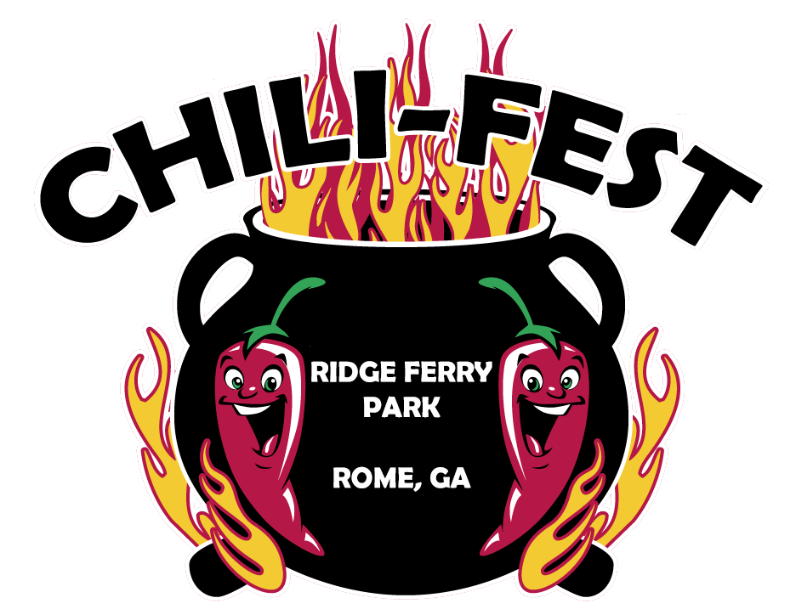

**Registration Form and Rules**

October 24-25, 2025

Friday 12:00 p.m. to Saturday 3:00 p.m.

Ridge Ferry Park, Rome, GA 30165



**General:**

1. The interpretation of the rules and guidelines are those of the contest organizer, in this case Rome-Floyd Parks and Recreation also referred to as RFPRA, and his or her decisions are final.
2. Registration:
   1. $50 per team.
   2. Cost include four event t-shirts and four wristbands, one recipe entry
   3. Additional cook sites are $50 - 20’x20’ cook site. includes 4 additional team member bracelets
   4. Registration ends October 10, 2025. Any registration after October 10 is not guaranteed an event t-shirt. T-shirt order will be placed October 13.
   5. No registration on Friday, October 24 or Saturday, October 25 will be accepted.
3. Event is rain or shine. There will be no refunds.
4. Check-in for cook teams will begin Friday, October 24 at 12:00 p.m. lasting until 6:00 p.m. at Ridge Ferry Park.
   1. Any teams to arrive after 6 p.m. will check in and receive team bucket and supplies at 8:00 AM Saturday morning prior to the cooks’ meeting.
5. Each team shall consist of a team leader and up to an additional 3-team members.
6. There will be a mandatory cooks’ meeting Friday evening at 6:00 p.m. Meeting can be earlier if everyone is present. Cooking and prepping may begin after.
7. Teams must cook a minimum of 15 gallons for judging and people’s choice.
8. Only cooks, cook team members, paid guests, sponsors and their guests and RFPRA officials are allowed in the park after 9:00 p.m. on Friday night. All attendees must wear event wristbands.
9. Contest Winners:
   1. Judge’s Competition:
   2. The top three chili recipes will be recognized.
      1. 1st Place - $500*

**\*Prize money is calculated on a minimum of 15 teams. If less than 15 teams compete, prize money will decrease. \***

* + 1. 2nd Place - $300*
    2. 3rd Place - $200*
  1. People’s Choice:
     1. 1st – 3rd Place – Trophies & Recognition
  2. Best Cook Site Set Up – receives recognition and certificate
  3. Best Team Name – receives recognition and certificate
     1. Please bring a poster with your team name to display at your table.

1. Each team will be assigned a cooking space size of 20’x20’. Pits, cookers, grills, props, tables, tents, or any other equipment (including generators) shall not exceed the boundaries of the team’s assigned cooking space. Teams shall not share an assigned cooking space or cooking device. Teams may purchase a second cook site for $50.
2. Teams shall provide all needed equipment, cooking ingredients, supplies and electricity.
3. Teams must adhere to all fire, electrical, health department and other codes. Contestants shall sign a form accepting responsibility for adhering to these codes. Teams must have a fire extinguisher on hand.
4. Each team is responsible for the maintenance and cleanup of its cooking area. The head cook will be responsible for the conduct and behavior of team members and guests. Any team leaving its space in such a condition that the space requires additional clean-up will be disqualified from participation at future events.
5. The excessive use of alcoholic beverages will be grounds for disqualification. Under NO circumstances are alcoholic beverages to be sold or offered in any form to the general public.
6. Contest chili may not be sold to the general public.
7. Fires shall be of wood, wood pellets, or charcoal. Gas and electric grills are permitted but you must provide your own propane and source of power (generators, etc.). Electrical accessories like spits, augers, or forced draft are permitted. Open pits or holes in the ground for fires are not permitted.
8. People’s Choice
   1. Saturday, October 25, the public will have the opportunity to taste test each team’s chili. Teams will be provided supplies for taste testing and a container for people’s ballots to go in. Any tampering of votes is an automatic disqualification from both People’s Choice and overall competition.
   2. Teams may not serve the chili directly to patrons. They must wear gloves and masks when putting chili in containers for tastings. Containers must be placed on table for patrons to pick up themselves so no direct contact is occurring.
   3. If you are cooking two recipes, you will still only have one container for People’s Choice voting.

**COVID Guidelines**

1. In the event that a team member is positive or has been exposed to COVID-19 within two weeks of the competition date, that team member may be replaced and the team may still compete so long as the remaining team members were not exposed.
2. Masks must be worn when around anyone outside of your team. (Ex: person walking up to booth, judges, check-in, etc)
3. Gloves must be worn while cooking. Hand sanitizer must be available at the booth.
4. There will be an enforcement team roaming during the contest to ensure the above rules are being followed.
5. All team entries require a signed COVID waiver.
6. Teams set up in locations to allow social distancing.
7. Signage throughout Ridge Ferry encouraging social distancing and mask wearing as well as advising anyone who is sick or has COVID symptoms not to attend.
8. All entries will be collected by Parks and Recreation Staff wearing gloves and masks.
9. Judges will be supplied with wipes, disposable gloves, hand sanitizer, and multiple plastic utensils to allow a new utensil to sample each entry.
10. For sampling, teams may not directly serve patrons. Teams must serve with masks and gloves and containers must be placed on table for patrons to pick up themselves, avoiding direct contact.

**Judging:**

1. All decisions of the judges will be final.
2. All teams should be ready for judging at 10:00 am on Saturday.
3. Only the entry to be judged is allowed in the container. Each entry will be judged on aroma, color, consistency, taste, and aftertaste.
   1. Aroma: Should smell appetizing
   2. Color: Should look appetizing
   3. Consistency: Should be a smooth combination of meat and gravy
   4. Taste: Should have full, rich flavoring and fresh zesty chili pepper taste. Blending of spices, how well they have permeated the meat
   5. Aftertaste: Should leave a pleasant taste after the fact
4. Scoring ranges from a low of 1 to a high of 10 in increments of 1 point for each category. Any entry that is disqualified will receive a score of zero for all four categories from all judges at the table.
5. An entry can be disqualified by the event organizer only. An entry can be disqualified for any of the following reasons:
   1. There is anything foreign other than competition chili in the container submitted for judging.
   2. The entry is turned in after the officially designated time.
   3. Gloves are not used while handling food products.
6. The event organizer will distribute cups for turn in. At turn in, event organizer will number cups to the corresponding team. The numbers will be random so it will be a blind judge and only the event organizer will know which team corresponds with which number. Organizer announces the number of cups to be judged and checks for rule violations as stated above. The cups will be passed around to the judges for sampling. The judge will then score each entry aroma, color, consistency, taste, and aftertaste. The event organizer makes sure that all scores for the chili entries are recorded in the proper place. This procedure is repeated for all containers. After each cup has been scored the event organizer will return the cups to the designated area. The event organizer will then collect the judging slips. The points from each category will be combined and the team with the highest total points will win.
   1. Tie Breaker
      1. In the event that one or more teams finish with the same number points in their division, judges will taste those entries only and judge between those.
      2. For overall winner purposes, the original scores will be used to decide the overall winner.
7. **People’s Choice**
   1. For People’s Choice, the general public will be voting for the best chili. The team with the most votes will be crowned People’s Choice. Votes will be counted following the official judging of the competition chili. All winners will be announced once scores are totaled and votes have been counted for the People’s Choice.

**Event Schedule**

*These times are potential to change. Teams will be notified of any changes VIA EMAIL.*

**Friday, October 24**

12:00 PM - Chili Teams Begin Arriving

6:00 PM – Cook team meeting; prepping and cooking may begin after.

9:00 PM - Quiet time starts

**Saturday, October 25**

7:30 AM – Staff arrive

8:00-9:00 AM – Check on teams

10:00 AM – Open to the public

10:00 - 10:30 AM – Chili turn in for Official Judging

2:30 PM – People’s Choice Judging Ends (**Or earlier if teams begin running out of chili. This is where cooking 15 gallons of chili might come in handy)**

3:00 PM – Chili Winners Announced. Event is over after winners announced.

Tyler Stinson – 762-235-4089; [tyler.stinson@floydcountyga.org](mailto:tyler.stinson@floydcountyga.org)

Mina Garcia – 706-728-8761; [mina.garcia@floydcountyga.org](mailto:mina.garcia@floydcountyga.org)

**Team Name: __________________________ Contact Name: _______________________________**

**# of Team Members: ____ Company/Organization: ___________________**

**Mailing Address: _______________________________________________**

**City: __________________ State: __________ Zip: _____________**

**Phone (Best #): ______________________ Email: _________________________________**

|  |  |  |
| --- | --- | --- |
| **Item (Please check ALL appropriate boxes for your entry)** | **Fee** | **Subtotal** |
| **Team Entry:** Entry guarantees 1 20’x20’ cook site, 4 t-shirts, 4 wristbands | **$50** |  |
| **Additional Cook Site:** (1) 20’ x 20’, includes 4 additional team member bracelets | **$50** |  |
| **Additional Team Member Bracelets:** Each team member is required a bracelet | **$5** |  |
| **T-Shirts:** Sizes and **quantity** of each.  S ____ M ____ L ____ XL ____ 2XL (+$5) ____  3XL(+$5)____ 4XL (+5) _____ | 4 t-shirts are included with first recipe entry. Pre-order additional shirts **$10**, 2XL/3XL/4XL additional **$5.** Shirts at event will be **$15.** |  |
| **Porta Toilet:** One (1) personal porta toilet on your cook site. | **$100** |  |
| **Registration is not complete until fees are paid in full.** | **Total Amount Due:** |  |

**Waiver of Liability:** In consideration of acceptance of this entry, I waive any and all claims for myself and my heirs against officials, sponsors, Rome-Floyd Parks and Recreation Authority, the City of Rome, Floyd County, and volunteers associated with this event from liability. Further, I hereby grant full permission to use any photographs, videotapes, motion pictures, recordings or other record of this event for any legitimate purpose. I agree to abide by the rules and regulations of the Chili-Fest.

**Signature: ___________________________________________ Date: __________________**

**Mail to:** Chili-Fest 2025, 1 Shorter Ave, Rome, GA 30165.

**Email to:** tyler.stinson@floydcountyga.org

**Payment Method (Check One):** Check payable to RFPRD or Credit Card (Once your application is received a staff member will contact you for card information)

**Waiver of Liability**

**Rome-Floyd Parks and Recreation, also referred to as RFPRA, including its officers, sponsors and/or associates and the contestants, including parents, and/or legal representatives, agree that RFPRA will in no case be responsible for any loss, damage, or injury regardless of how much loss, damage, or injury is occasioned, and indemnify and save harmless RFPRA from any and all claims, suits, and/or judgments including the cost for defense of and such claim and/or suit by RFPRA brought by anyone as a result of any loss, damage, or injury to any person or property, occasioned by any action or inaction of contestant, either solely or in conjunction with RFPRA. Further, I hereby grant full permission to RFPRA and/or agents authorized by them, to use any photographs, videotapes, motion pictures, recordings or any other record of the event for any legitimate purpose. I have read and agree to abide by the rules and guidelines governing the Chili-Fest.**

**Signature: __________________________________________________**

**Date: __________________________**